ADDRESS OF WELCOME
PRESENTED TO
HONORABLE MR. SYED MURTAZA MAHMUD
FEDERAL MINISTER FOR INDUSTIES & PRODUCTION.
BY Zahid Mahmood Qureshi

PRESIDENT, PAKISTAN SOCIETY OF SUGAR TECHNOLOGISTS

The Honorable Chief Guest Mr. SYED MURTAZA MAHMUD,
CEO’s of the Sugar Mills, Mr. Felipe Lermen, Brazilian Diplomat,

Distinguished guests, Learned Delegates, Ladies and Gentlemen.

Assalam-o-Alaikum,

On behalf of the Pakistan Society of Sugar Technologists, I welcome the honorable Chief Guest Mr. SYED MURTAZA MAHMUD, Federal Minister for FEDERAL MINISTER FOR INDUSTIES & PRODUCTION who very kindly accepted our request and spared time out of his busy schedule to inaugurate the 54th Annual Convention of PSST.

We are indeed thankful to you sir.

We are also thankful to the distinguished guests, foreign delegates, PSMA Members and fellow delegates of the society who have come all the way to attend this convention.

1)—PSST was founded in 1955 for the main purpose of sharing and dissipating knowledge among the sugar technologists. In the past 67 years the society, has rendered remarkable services in all disciplines of the industry. One convention and four workshops are held every year to impart knowledge, experience and new ideas among the members of the society. The record of these presentations is permanently preserved.

Sir,

2)--In 1947 at the time of coming into existence of our country we had only two (2) sugar mills and today we have as many as 90.

Sir,

3)--The sugar industry enjoys the position as one of the major industries of our country. It not only Contributes billions of rupees every year in national Exchequer on account of sales tax/ income tax and road cess fund but also directly helps the development and growth of rural economy through purchase of cane and extending financial loans as well as technical assistance to the farmers for the development of cane.

4)--It would be for your kind interest to mention here that during the last 67 years there has been a significant growth in the cultivation of sugar cane as compared to other major crops of the country. But still it is a moment of concern that we stand below the international standard, in terms of sugar and sugar cane yield, among the major cane growing countries of the world.

- Average sugar cane yield of Pakistan compared to India, Egypt & Mexico is shown below
- District wise yield of Punjab is also shown in graph
- Potential to increase yield, sugar content and potential for export of sugar is shown in graph

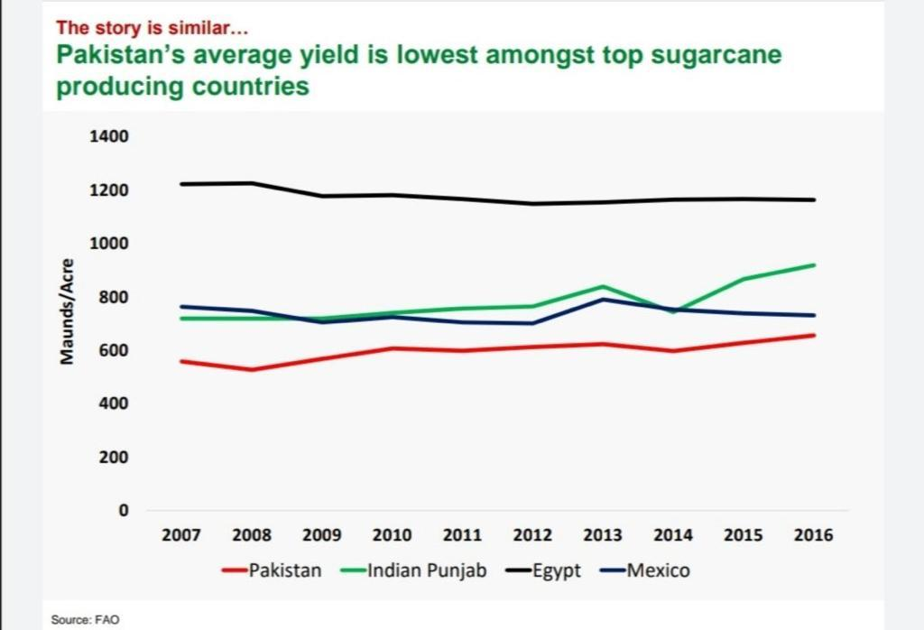

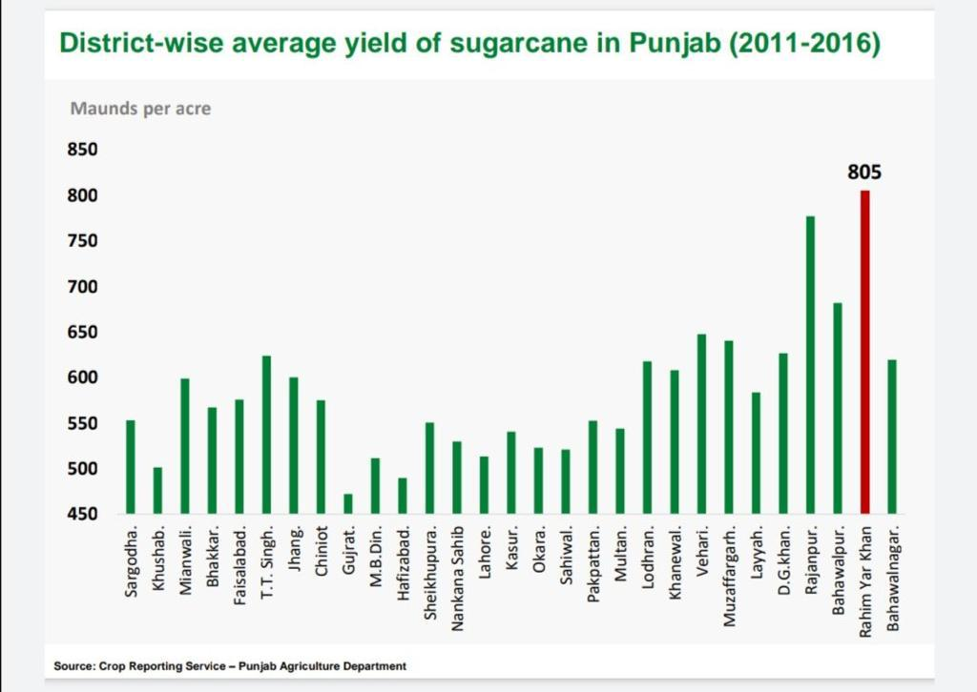

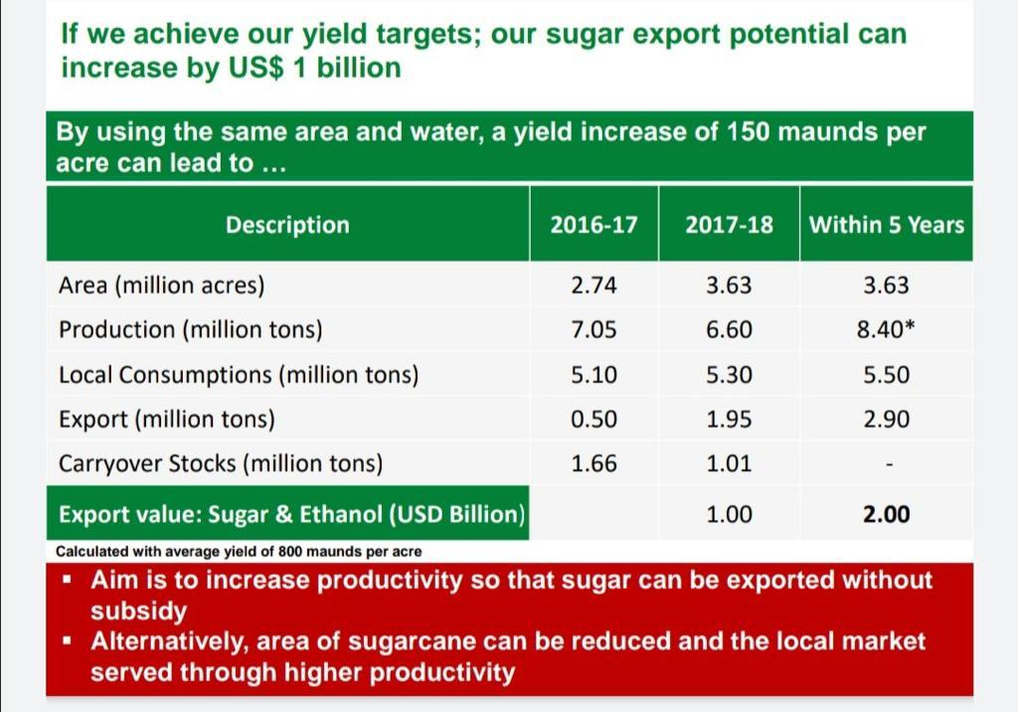

Sir,

5)--During previous two decades vertical growth of the sugar industry has enabled it to produce 8.0 Million tons of sugar during season 2021-22 against estimated consumption around 5.5-6.0 Million tons per year. Thus, it was 2.0 million tons surplus during 2021-22 than the estimated consumption.

Production is more than domestic need.

Sir,

This surplus sugar could be exported and foreign exchange can be earned required for economy.
But unfortunately, it has not done so far. As a result, availability of surplus sugar has crashed sugar prices in domestic market and sugar mills are forced to sell at much low price than cost of production to pay off loans to banks.

Free market for sugar cane as well as for sugar is required in Pakistan.

Pakistan Sugar Industry can play a role of Engine of Growth of Pakistan Economy if GOP takes following measures,

Roadmap for Prosperity of Economy, Industry, Farmers & Society:

- Pakistan is an agricultural country. This strength needs to be utilized.
- GOP to join hands with scientists, sugar industry, farmers.
- Declare agriculture emergency
- Resources, support, incentives to be announced for scientist to perform
- Target should be to increase per acre yield & sugar recovery. In next 5-years, Pakistan can produce more than 12 million Tons of sugar with same area under sugar cane
- Revenue of farmer will be doubled and low cost of production
- Industry cost of production will be reduced
- Export of sugar without any subsidy & big source of foreign exchange

Solar Energy a great source of renewable energy:

- Price of diesel, electricity for agriculture is very high, increasing cost of farmers
- Import of diesel for agriculture purpose and for power generation is burden on economy and waste of foreign exchange
- Causing environmental hazards through use of petroleum products
- GOP should encourage solar systems for farmers to reduce cost, foreign exchange and envoi mental benefits

Sugar Industry, a source of Green Energy at Low Cost:

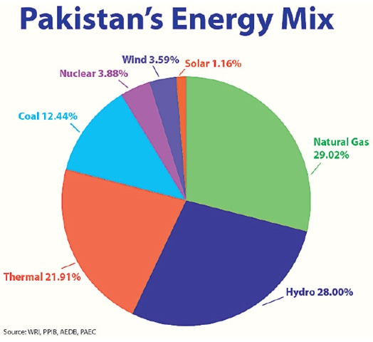

- GOP is spending billion of dollars on import of petroleum products, coal, RLNG for power generation
- Cost of power generation & distribution to consumers is very high
- It is a major source of pollution, envoirmemtal hazards
- Sugar Industry of Pakistan can play vital role in export of cheap electricity using biomass
- Pakistan Sugar Industry can export 1000-1200 MW electricity if GOP revive Upfront Tariff Policy for bagasse-based power.
- GOP should also ensure continuity in policy as sugar industry has faced heavy financial losses due to discontinuity in policies.

Ethanol Blending Policy a way forward towards sustainable mobility:

There are more than 20 ethanol plants working and exporting ethanol. This ethanol may be used as fuel in automobiles with following benefits,

- GOP is spending billion of dollars every year to import petroleum products
- Use of petroleum products is creating environmental hazards, pollution
- GOP should announce ethanol blending policy using locally produced ethanol to save economy, environment & health of society
- Brazil is world leader in using ethanol blending policy

POWER POINT SLIDES

Sir,

12)--Before Concluding, it would not be out of place to mention for the kind attention of worthy Chief Guest that although PSST has been awarding gold medals, shields and certificates to the individual research scholars of sugar industry, our 60 years of voluntary contribution towards the national development has never been able to catch eye of the concerned authorities, for recognition at national level.
Sir,

We are silent contributors with commitment and a cause to national development. We deserve recognition at the national level on merit. Our scientists present research articles at the international conferences and are recognized, but are not given any weight home.

In the last,
I, once again extend my heartiest gratitude’s to the honorable Chief Guest, the distinguished guests and all the participants of convention on my behalf and on behalf of the PSST.

Thank you very much, Sir.

